South Dakota Junior Honor Choir 2020
January 17-18, 2020
Rapid City, SD

Dear 7th and 8th graders,

MMS gives you to opportunity to audition for Junior Honor Choir. This is a very select group of singers in South Dakota and it would be an honor to be part of.

SD Junior Honor Choir features TWO CHOIRS of the most gifted and artistic singers in our state, a SATB mixed choir of approximately 92 voices and a Women’s Choir of approximately 84 voices. For a successful experience these students must exhibit:

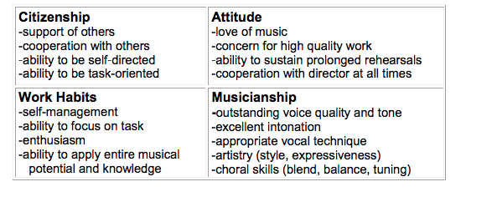

September 3rd-October 5th
Mrs. Heeren will help you prepare for your audition, record your audition, and send it in online.

• Scale: Each singer will sing, a cappella on a neutral syllable or in solfege a one octave diatonic scale, first ascending then descending, starting on one of the pitches given below. Starting pitch MUST be heard on the audition. Soprano F, G, or A above middle C Alto C, D, or E above middle C Tenor F or G below middle C Bass B, C, or D below middle C

• America (My Country ‘Tis of Thee): Starting on the pitches listed below, sing the first stanza unaccompanied. Starting pitch MUST be heard on the audition. Accompanied singers will be disqualified. Soprano A above middle C Alto F above middle C Tenor G below middle C Bass C below middle C

• Repertoire selection: “Glory to God,” Handel/arr. Liebergen CM8392, SATB.
Sing measures 5-28, unaccompanied at a tempo of approximately 115-125. Note:
All voices omit the full measures of rest in measures 9-11 and 17-20.

Financial Commitment
There is a $145 registration fee that will cover motel room for Friday evening, T-shirt, 3 meals, clinician, accompanist and other Junior Honor Choir expenses.
If accepted, the Mitchell School District will help where they can with the financial commitment. We won’t know how much will be contributed until we see how many students make Junior Honor Choir

------------------------------------------------------------------------------------------------------------

Return this signed form to Mrs. Heeren to start the audition process
I give permission for my student to send in an audition recording and understand the financial commitment.

Students Name:______________________________________

Parent Signature:______________________________________

